Contractor/Vendor Application Packet
This Contractor/Vendor Application Packet includes the necessary materials for you to be considered for future work for Choptank Electric Cooperative (“Choptank” or “the Cooperative”). Please complete the Packet fully and to the best of your ability and return to the Cooperative per the instructions below. Incomplete Packets will not be considered. Submittal of this Packet does not guarantee future work with the Cooperative; however, it makes the Cooperative aware of your interest and fast-tracks the process in the event your company is selected for work.

Submittal of this Packet grants the Cooperative permission to contact your references and make inquires, as needed, with local, state and federal agencies. The information you provide will remain on file for one (1) year from the date of receipt and will be removed from our records at that time.

If you have any questions regarding this Packet, please contact Sarah Dahl at 410-479-8613. Thank you for your assistance in completing this Packet.

Checklist
Please ensure you have completed or attached the following forms requested by the Cooperative:

_____ Contractor/Vendor Information Summary Form
_____ Copy of State of Maryland Business License
_____ Copy of Additional Licenses (if requested)
_____ Copy of Insurance Documentation Form
_____ Proposed Contractual Rates (template provided, or submit in your standard format)
_____ Supplier Diversity Form
_____ IRS W-9 Request for Taxpayer Identification Number and Certification
_____ Electronic Payment Form (optional)
_____ Statement of OSHA Compliance

Return completed Packets to:

Choptank Electric Cooperative, Inc.
Attention: Sarah Dahl
P.O. Box 430
Denton, MD 21629-0430

Contractor/Vendor Information Summary
Please complete all applicable information to the best of your ability.

Company Name: ________________________________________________________________

Primary Contact: ________________________________________________________________

Address: ________________________________________________________________

City: ___________________________ State: ____________ Zip Code: __________

Phone: Office: ____________________ Mobile: ____________________

Email: ___________________________________________________________________

Summary of Proposed Work Activities: __________________________________________________

___________________________________________________________________________________
Category:
□ Construction □ Vegetation Management □ Facilities □ Supplier □ Fleet □ Other

Federal Employee Identification #: __________________________________________________

State of Maryland Business License #: __________________________________________________

(Note: Based upon description of work, you may be asked to provide additional license information; such as but not limited to State of Maryland Pesticide License, etc.)

Insurance Company: ________________________________________________________________

Insurance Policy #: _______________________ Phone Number: ______________________

(Please provide a copy of your company’s insurance documentation form)

Please provide two (2) references for which you have performed work:
Name: ________________________ Name: ________________________
Organization: ________________________ Organization: ________________________
Phone #: ________________________ Phone #: ________________________
Proposed Contractual Rates

January 2018

Choptank Electric Cooperative, Inc.
P.O. Box 430
Denton, MD 21629

RE: 1/01/20_____ through 12/31/20_____ Rates

Dear Staff of Choptank Electric Cooperative,

Please find below the hourly rate for ____________________________________________________.

This rate would include all employee, equipment, and when necessary extended travel expenses. The hourly billing rate(s) would be as follows:

Specialized Activities 20_____

Unit / Description | Price/Hour
Verification of Rates (Initial Here)

This billing rate would be in effect for the period specified above and is subject to change upon agreement of both myself and the Cooperative. I would like to thank you for the opportunity to submit the above rate. If you have any questions, please contact me at your convenience.

Regards,

Rate is accepted:

_______________________________________ ___________________
Signature Date

_______________________________________
Title
Supplier Diversity: Background and Definitions
Please use this information to complete the supplier diversity form that follows. Any information you choose to provide is voluntary and provided for the purpose of promoting diverse suppliers.

Choptank signed a Supplier Diversity Memorandum of Understanding (MOU) with the Maryland Public Service Commission (PSC). This MOU encourages Choptank to provide the maximum reasonable opportunity for Diverse Suppliers to participate in and compete for contracts and subcontracts in Choptank’s supply chain for goods and services. Per the MOU, a “Diverse Supplier” is defined as any legal entity that is:

- Organized to engage in commercial transactions;
- At least 51% owned and Controlled by one or more individuals who are Socially and Economically Disadvantaged; and
- Managed by, and the daily business operations of which are Controlled by, one or more of the Socially and Economically Disadvantaged Individuals who own it.

A Diverse Supplier includes a not-for-profit entity that is organized to promote the interests of physically or mentally disabled individuals.

A “Socially and Economically Disadvantaged Individual” means a citizen or lawfully admitted permanent resident of the United States who is in any of the following minority groups:

- African-American – an individual having origins in any of the black racial groups of Africa; or
- American Indian/Native American – an individual having origins in any of the original peoples of North America and who is a documented member of a North American tribe, band, or otherwise has a special relationship with the United States or a state through treaty, agreement, or some other form of recognition. This includes an individual who claims to be an American Indian/Native American and who is regarded as such by the American Indian/Native American community of which the individual claims to be a part, but does not include an individual of Eskimo and Aleutian origin; or
- Asian – an individual having origins in the Far East, Southeast Asia, or the Indian subcontinent, and who is regarded as such by the community of which the person claims to be a part; or
- Hispanic – an individual of Mexican, Puerto Rican, Cuban, Central or South American or other Spanish culture or origin, regardless of race, and who is regarded as such by the community of which the person claims to be a part; or
- Service-Disabled Veteran – A veteran who possesses a disability rating letter issued by the Department of Veterans Affairs, establishing a service-connected rating between 0 and 100% or a disability determination from the Department of Defense; or

- Physically or mentally disabled – an individual who has an impairment that substantially limits one or more major life activity, who is regarded generally by the community as having such a disability, and whose disability has substantially limited his or her ability to engage in competitive business; or
- Women – a woman, regardless of race or ethnicity.

The PSC has also requested that Choptank track and report data on contracts with two additional categories:

- Veteran-owned businesses
- Lesbian, Gay, Bisexual, and Transgender (LGBT)-owned businesses

Supplier Diversity Form

- Contact name and information to verify supplier diversity qualifications:

Name: __________________________________________________________________________________
Address: __________________________________________________________________________________
Phone: _________________________ Email: ___________________________________________

- Service(s) or product(s) you will provide to Choptank Electric:

____________________________________________________________________________________________

- Classification (Please check all that apply):

Choptank Electric may request additional information based upon the items in this section that are marked. For more information on the definitions associated with Supplier Diversity, please refer to the information provided on the previous two pages or to the Maryland Public Service Commission’s Supplier Diversity website at: http://webapp.psc.state.md.us/Intranet/utility/sdiversity_new.cfm.

_____ Not-for-profit entity organized to promote the interest of physically or mentally challenged persons
_____ African American-owned business (51% ownership)
_____ American Indian / Native American-owned business (51% ownership)
_____ Asian-owned business (51% ownership)
_____ Hispanic-owned business (51% ownership)
_____ Service-Disabled Veteran-owned business (51% ownership)
_____ Veteran-owned business (51% ownership)
_____ Physically or mentally disabled-owned business (51% ownership)
_____ Women-owned business (51% ownership)
_____ LGBT-owned business (51% ownership)
_____ None of the above / Decline to answer

- Are you certified by a Third Party Certifying Agent?

_____ YES – Please list the Agent’s name: __________________________________________________
_____ NO

- Please identify which North American Industry System (NAICS) 6-digit code number classification your service(s) and or product(s) fall under. (See www.naics.com/search.htm for a search engine listing all NAICS codes.)

Service / Product: _________________________ NAICS 6 Digit Code: ____________________
Service / Product: _________________________ NAICS 6 Digit Code: ____________________
Service / Product: _________________________ NAICS 6 Digit Code: ____________________
Service / Product: _________________________ NAICS 6 Digit Code: ____________________

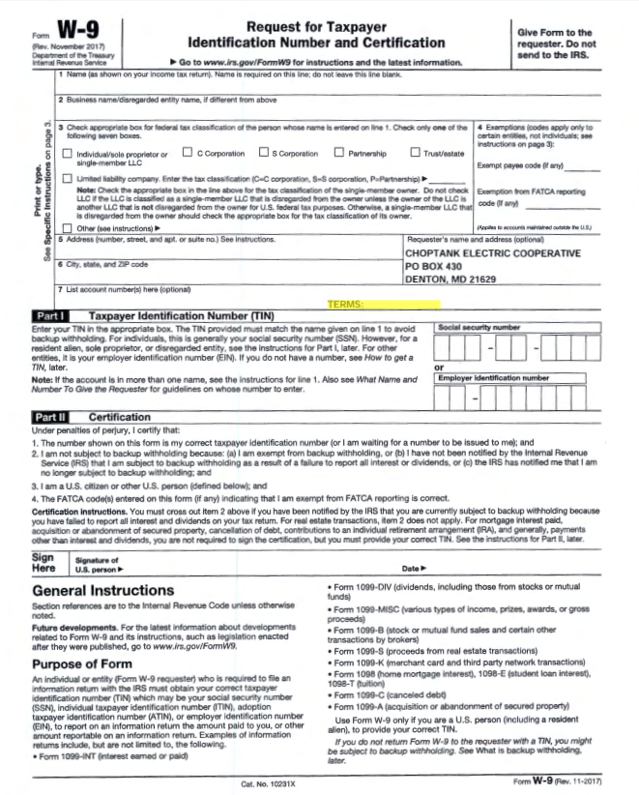
Electronic Payment Form (Optional)
PLEASE NOTE: Submittal of this form is optional. If you choose to submit this form, it will expedite payment in the event you are selected to perform work and/or provide services.

Vendor Name: ______________________________________________________________________

Please select the ONE method of payment you wish to receive from the Cooperative:

_____ Credit card (Please note: If you select this option, you will be contacted by the Cooperative’s third party e-payment vendor to complete payment set-up):

Please provide:
Contact Name: __________________________ Phone #_________________
Email Address: _________________________________________________________

_____ ACH/Direct Deposit

Please provide:
Bank Name: _________________________________________________________
Bank Telephone #: _________________________________________________________
Account Type: (Please Check One) _____ Checking _____ Savings
Bank 9 Digit Routing #: _________________________________________________________
Account #: _________________________________________________________
Email Address for Payment Verification: _____________________________________

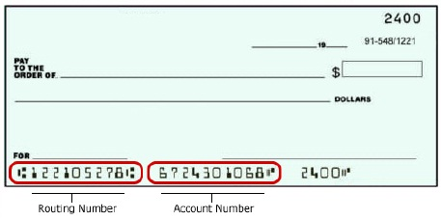

Please provide your information by either email or mail to:

apinvoice@choptankelectric.coop OR Choptank Electric Cooperative
Attention: Nikki Welzel
PO Box 430
Denton, MD 21629

PLEASE NOTE: TO ENSURE TIMELY PAYMENT OF ALL INVOICES TO YOUR DESIRED ACCOUNT, INVOICE MUST BE SUBMITTED BY EMAIL TO: apinvoice@choptankelectric.coop
Statement of OSHA Compliance
CONTRACTOR’S STATEMENT OF COMPLIANCE WITH THE OCCUPATIONAL SAFETY AND HEALTH ACT

_____________________________________________________ is proposing to perform services for
(Name of Contractor)

Choptank Electric Cooperative, Inc., and hereby certifies to the following:

_____________________________________________________ has knowledge of the Occupational
(Name of Contractor)

Safety and Health Act (OSHA) with additions, revisions and/or modifications as well as any state and local regulations or requirements.

Our employees and equipment will comply with the Act and/or additions, revisions, and/or modifications and any present or future state and local regulations or requirements.

Our company will be responsible for any infraction of the Occupational Safety and Health Act requirements, additions, revision, and/or modifications and any state and local regulations or requirements.

ATTEST: _______________________________________________
Contractor

__________________________ By:________________________________
Secretary or Witness
Title:_______________________________

Date:_______________________________

http://www.psc.state.md.us/wp-content/uploads/Choptank-MOU2.pdf
“Control” means exercising the power to make policy decisions.
See PC 16 Public Determination dated October 5, 2018, available at https://webapp.psc.state.md.us/newIntranet/AdminDocket/NewIndex3_VOpenFile.cfm?ServerFilePath=C%3A%5CAdminDocket%5CPublicConferences%5CPC16%5C340%2Epdf.

